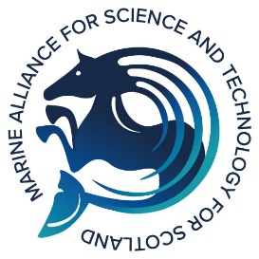
We would appreciate your co-operation in completing this form. This will enable the most appropriate NatureScot staff to consider applicants for your PhD Internship of choice. The information you give will be treated with the strictest confidence.

Application Form for Proposals for NatureScot PhD 3-month Internship
A. INFORMATION ABOUT THE PROPOSED INTERNSHIP PROJECT
- Proposed project title you are interested in.

Source-to-sea: taking stock of the coherence of policy and regulatory mechanisms, and the supporting scientific knowledge, to manage the downstream ecosystem consequences of activities on land and in freshwater.
(Perth (Battleby) host but flexible working location) ☐

- Background and rationale of your suitability to the internship project. Please include relevant experience and skills that you can offer to achieve the outcomes and deliverables proposed. Why is this project important to you? What aspects are you particularly interested in and why? (max 1000 words).

(Please tell us about previous relevant experience, including educational and professional qualifications. Continue on a separate sheet if necessary. Please also enclose a copy of your CV).

- Is the proposed schedule and/or timetable for work during this internship suitable for you or requiring discussion? (3-month internship to be completed in financial year 2022-23 – see section 8 in proposal for specific timings) (max 300 words)

- Do you hold a current UK driving licence?
Yes ☐
No ☐

- Please add any other information that might be helpful, if relevant.

B. PERMISSION AND REFEREES
You should have discussed this opportunity with your PhD supervisor and have their permission to suspend your PhD studies to undertake an internship. We will let you know if we intend to seek references.
- Primary University Supervisor’s Name and email address

- Name and email address of additional referee

C. APPLICANT INFORMATION
- Applicant Name

- Applicant Address

- Applicant email address

